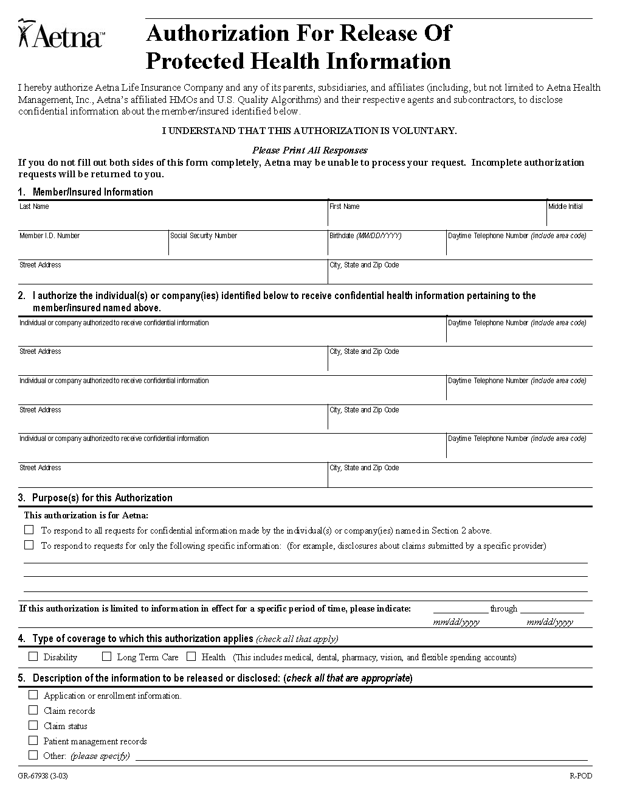
Karen Marcetti
MHA Insurance Company (517) 323-3443

6215 West St. Joseph Highway Lansing, MI 48917
X

X Any and all records generated by ER visit dated 5/16/05; ER visit dated 5/17/05; Admission dated 5/17/05 to include just the typewritten reports as follows: Face Sheet, Discharge Summary, History & Physical, Operative Reports; Consultations and any other typewritten summaries pertaining to Karen Marcetti SSN: XXX-XX-5076, DOB: 12/22/1965.

Order No. 01-12345 - 003 (1 of 2)
Axiom Requisition Copy Service as agent of MHA Insurance Company (877) 886-5090

2869 Jolly Rd Okemos, Michigan 48864
X
X
X
X
XXX-XX-5076

12/22/1965

,
X X X
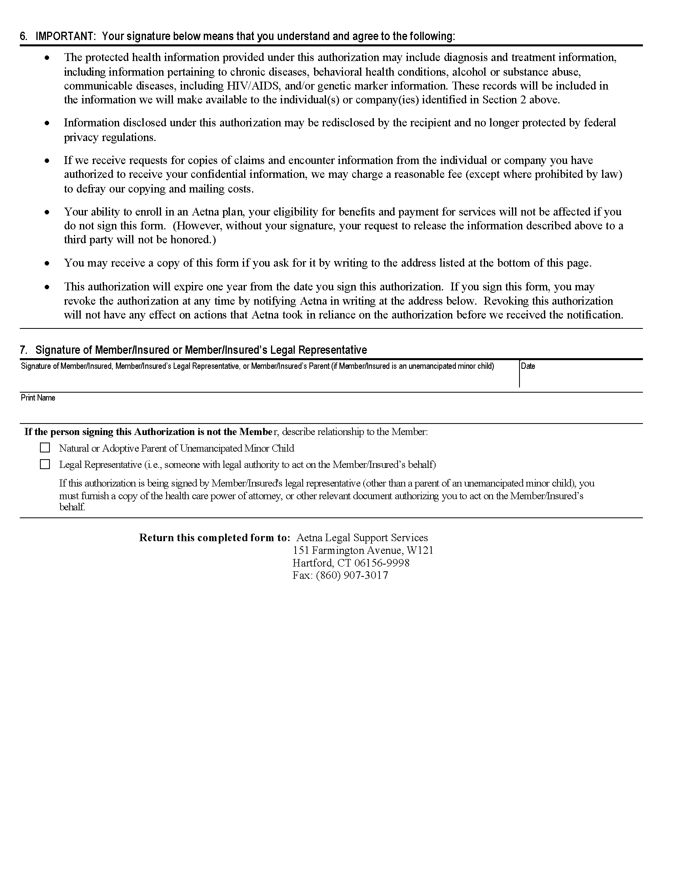
Order No. 01-12345 - 003 (2 of 2)
Karen Marcetti

